Hello,

We are very excited to welcome you to the English Language and Literature course at Hartismere!

English Language:

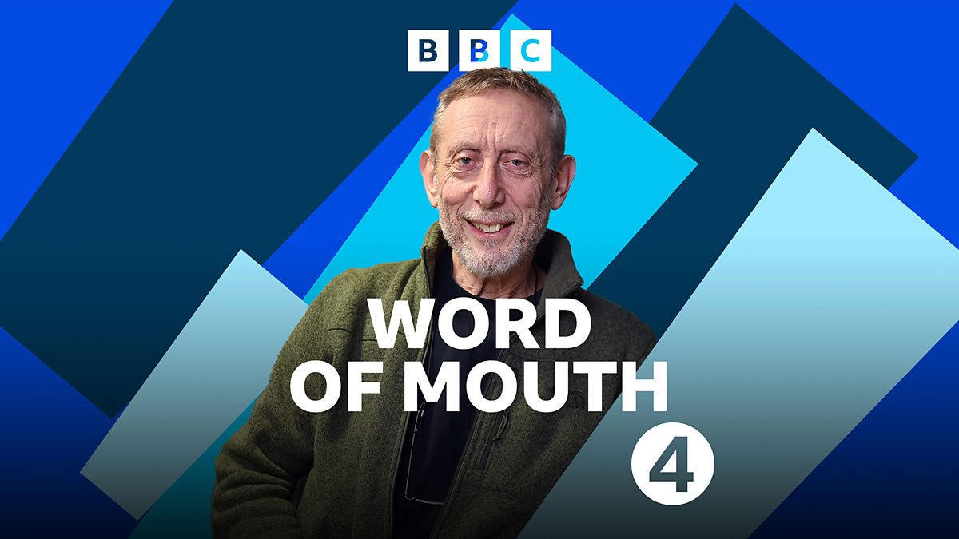
The best preparation for this part of the course is to get interested in a range of different debates and discussions about language and linguistics in general.

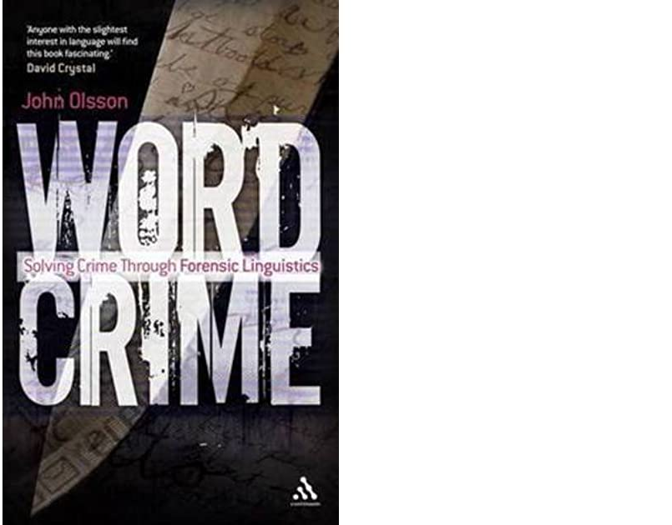
- BBC Radio 4 have a great programme called Word of Mouth. There are lots of interesting English Language related things to listen to here: https://www.bbc.co.uk/programmes/b006qtnz

- The study of English Language is closely linked to Linguistics (the scientific study of language). An exciting area of this is Forensic Linguistics and how language can be used to solve crimes and absolve people wrongly accused of committing crimes. Find out more by reading ‘Word Crime - Solving Crime Through Forensic Linguistics’ by John Olsson or watching a variety of Ted Talks or YouTube videos that can be found online on the topic.

- Why not use all this spare time you have learning how to use linguistics to become a better liar? Find out more here: https://ed.ted.com/lessons/the-language-of-lying-noah-zandan

English Literature:

- Read, read, read...and read some more! Here is a good place to start: https://thegreatestbooks.org/lists/160

- While you have some time on your hands, you might want to expose yourself to some good quality novel to film adaptations too: https://www.theguardian.com/film/2006/jun/02/filmadaptations1

